Docker Commands

**1.docker –version**

This command is used to get the currently installed version of docker.

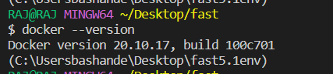

**2. docker pull**

**Usage: docker pull <image name>**

This command is used to pull images from the **docker repository (docker hub).**

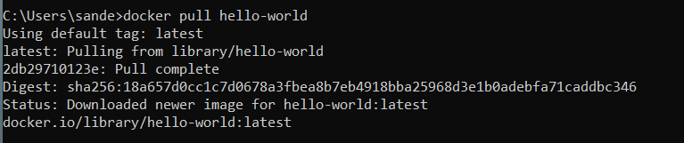

**3. docker run**

**Usage: docker run -d -p <image name>**

This command is used to create a container from an image.

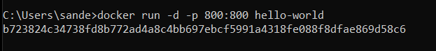

**4. docker ps**

**Usage: docker ps**

This command is used to list the running containers.

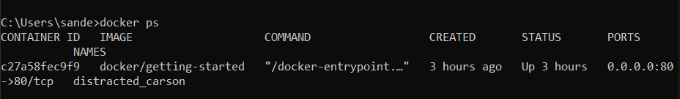

**5.docker ps -a**

**Usage: docker ps -a**

This command is used to show all the running and exited containers.

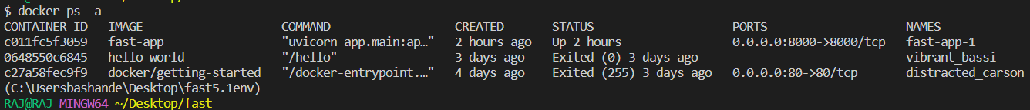

**6. docker stop**

**Usage: docker stop <container id>**

This command stops a running container.

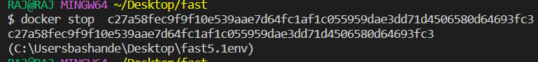

**7. docker kill**

**Usage: docker kill <container id>**

This command kills the container by stopping its execution immediately.

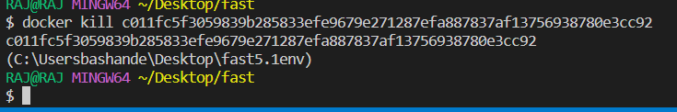

**8. docker commit**

**Usage: docker commit <container id> <username/image name>**

This command creates a new image of an edited container on the local system.

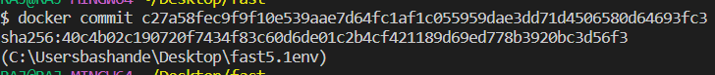

**9. docker login**

**Usage: docker login**

This command is used to login to the docker hub repository.

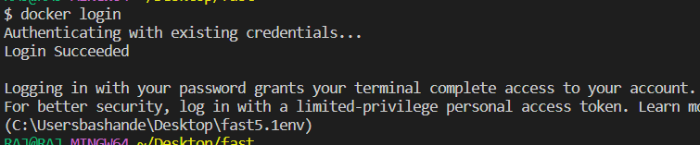

**10. docker push**

**Usage: docker push** **<username/image name>**

This command is used to push an image to the docker hub repository.

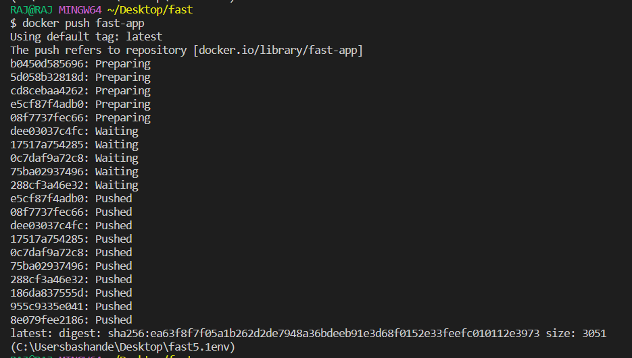

**11. docker images**

**Usage: docker images**

This command lists all the locally stored docker images.

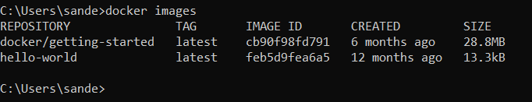

**12. docker rm**

**Usage: docker rm <container id>**

This command is used to delete a stopped container.

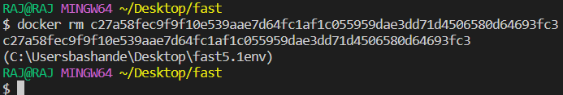

**13. docker rmi**

**Usage: docker rmi <image-id>**

This command is used to delete an image from local storage.

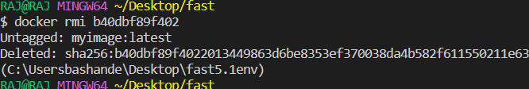

**14. docker tag**

**Usage: docker tag <username/image name>**

This command is used to provides a unique identity to a docker image.

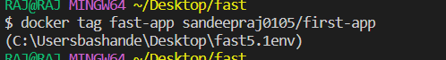

**15. docker build**

**Usage: docker build -t < image name>**

This command is used to build a docker image from a specific docker file.

